Read the short article about the endangered, American Crocodile and make notes for the given headings.

American Crocodile
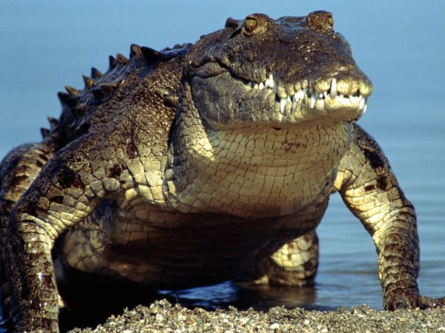
The American crocodile is considered an endangered species in nearly all parts of its North, Central, and South American range. Survey data, except in the United States, is poor or non-existent, but conservationists agree that illegal hunting and habitat depletion has reduced populations of this wide-ranging reptile to critical levels.
A small, remnant population lives in southern Florida, but most are found in southern Mexico, Central America, the Caribbean, and northern South America. Their habitat of choice is the fresh or brackish water of river estuaries, coastal lagoons, and mangrove swamps.
A prehistoric-looking creature, it is distinguishable from its cousin, the American alligator, by its longer, thinner snout, its lighter colour, and two long teeth on the lower jaw that are visible when its mouth is closed.
This species is among the largest of the world's crocodiles, with Central and South American males reaching lengths of up to 20 feet (6.1 meters). Males in the U.S. population rarely exceed 13 feet (4 meters), however.
Their diet consists mainly of small mammals, birds, fish, crabs, insects, snails, frogs, and occasionally carrion. They have been known to attack people, but are far more likely to flee at the sight of humans.
Most countries in the American crocodile's range have passed protection laws, but unfortunately, few governments provide adequate enforcement.
Reasons why the population has decreased.
- …………………………………………………………………………………………………………………….
- …………………………………………………………………………………………………………………….
Various habitats
- …………………………………………………………………………………………………………………….
- …………………………………………………………………………………………………………………….
How to distinguish a crocodile from an Alligator
- …………………………………………………………………………………………………………………….
- …………………………………………………………………………………………………………………….
Diet
- …………………………………………………………………………………………………………………….
- …………………………………………………………………………………………………………………….

